

Two Months Progress Report

SIDBI – PMU Uttar Pradesh

January-Febraury 2023

**Activities performed by PMU during January-February 2023**

**Activities performed by PMU during January -February -2023**

|  |
| --- |
| **Details of activities carried out** |
| **Policy Advocacy** |
| 1. **Preparation of Modalities of Pledge scheme (MSME Department)**   PMU Team along with GM, SIDBI, ROLK met the ACS, and shared modalities that can be adopted by the MSME department for financing private developers at subsidized rate for establishment of Industrial Park.  PMU team also held one virtual meeting with SIDBI officials (Mr. Acharya, CGM and Ms Mamta Ravi of SCDF team) and explained potentials and drawbacks PLEDGE scheme |
| 1. **Raising and Accelerating MSME Performance (RAMP)**   PMU team along with GM,SIDBI and DGM, SIDBI ROLK connect with State Nodal Officials, and attend meeting with relevant stakeholders to discuss on development of State Strategic Investment Plan (SIP). SIDBI proposed extension of the support of Swavalamban Connect Kendra (SCK) in gathering and collating the primary information of the budding entrepreneur and provide that to the MSME department. |
| **Enhancing Credit Flow to MSMEs** |
| 1. **Trade Receivable e-Discounting System (TReDS)**  * PMU team along with the GM, SIDBI meet with the Chief Secretary on January 25, 2023, and explained the salient features of TREDS and requested to initiate the process of onboarding the TReDS platforms and issuance of guidelines for Public Sector Units for onboarding on these platforms. * PMU team along with the GM, SIDBI meet with the Principal Secretary on February 21, 2023, and explained the salient features of TREDS and requested to initiate the process of onboarding the TReDS platforms and issuance of guidelines for Public Sector Units for onboarding on these platforms. * PMU team along with the GM & DGM, SIDBI meet with the Additional Chief Secretary on February 23, 2023, and requested to initiate the process of onboarding the TReDS platforms and issuance of guidelines for Public Sector Units for onboarding on these platforms. |
| 1. **Credit Guarantee Fund Trust for Micro and Small Enterprises (CGTMSE)**  * PMU team along with the GM, SIDBI meet with the Chief Secretary on January 25, 2023, and explained the salient features of CGTMSE and requested to establishment of corpus fund for CGTMSE so that MSME can avail collateral free loan. * PMU team along with the GM, SIDBI meet with the Principal Secretary on February 21, 2023, and explained the salient features of CGTMSE and requested to establishment of corpus fund for CGTMSE so that MSME can avail collateral free loan. |
| 1. **General agreement with RRBs**   In accordance with RBI circular SIDBI ROLK through PMU is facilitating General Agreement with RRBs in UP. In this regard, PMU had approached 3 RRBs in the state- 1. Prathama Bank 2. Baroda bank of UP and 3. Aryavart Bank.  Status Update on General Agreement with 3 RRBs in UP are-   1. **Prathama Bank**- GE to be done in March first week in Moradabad. 2. **Baroda bank**- The bank has yet to give confirmation for signing of the MoU 3. **Aryavart Bank**- SIDBI PMU did multiple follow up with Aryavart – as on Feb 23, 2023, it has taken approval from their board and ready to execute MoU. MoU is expected in March first week. |
| 1. **Credit Delivery Arrangement (CDA) with NBFCs--**   Selection of reputed & competent NBFCs under SIDBI indirect lending model to spread the outreach of SIDBI to MSME sector.  In continuation with work done in last months which include sorting of top ranked NBFCs operational in UP. PMU with ROLK had discussion with 10 interested NBFCs including IIFL, Aye finance and Samunnati Credit to explore possible collaboration for MSME finance under Channel Financing model in state of UP. Recently a communication to invite the application is sent to interested NBFCs and regular follow up to receive their application is underway. |
| **Strengthening Infrastructure for MSMEs** |
| 1. **Establishment of Private industrial Parks –**   Under the recently approved PLEDGE scheme the MSME department is offering financial support to private developers for establishment of industrial park in 10 acres to 50 acres. 75% of developed plots shall be allocated to the MSME sector. SIDBI has offered to provide the corpus fund for this scheme. |
| **Convergence -Twinning with GoI schemes for MSME & Cluster Development** |
| 1. **Green Financing** –   PMU team has organised one virtual meeting with Mr. Anupam Shukla, IAS, Director, UPNEDA and Mr. R K Singh, CGM, Green Finance Vertical and Mr Manish Sinha, General Manager, SIDBI, ROLK on January 24,2023. During the meeting SIDBI officials presented various schemes offered by the SIDBI under green financing components and offered a bouquets of schemes that UP government can leverage for sustainable industrial development. |
| 1. **PM-KUSUM (Pradhan Mantri Kisan Urja Suraksha Evam Utthaan Mahabhiyan) –**   A detailed discussion held between Green Finance Team, SIDBI, UPNEDA and energy service company (ESCO) Tata/Reddington etc. to present modalities for financing PM KUSUM and Roof Top Solar Power project in Ayodhya on January 27,2023 |
| 1. **Solar Roof Top Financing –**   One significant meeting was facilitated by PMU between SIDBI, UPNEDA and RESCO on February 17, 2023, in which SIDBI and UPNEDA have agreed to enter into an agreement for greening the heritage cities by the installation of PV Solar Rooftop on 12500 household units in Ayodhya in phase I. The other parties to the agreement are – Ayodhya Municipal Corporation and PV Solar Vendors |
| **Institutional Strengthening & Capacity Building of stakeholders** |
| 1. **Arrangement on SIDBI/Uttrayani Swavalamban Mela**   SIDBI ROLK sponsored 30 Stalls in the mela.SIDBI DMD Shri VSV Rao visited the Mela and interacted with the artisans from marginalized groups and weaker sections are being given an opportunity to display and sell their products. The event is aimed to serve a social cause by assisting the artisans to generate income through sale of products. In this event around 200 artisans have shown their products. Approximately 8000-10000 citizens had visited on daily basis  PMU Team assisted ROLK in dissemination various direct, indirect loan and green finance scheme to the visitors and to the exhibitors. |
| **Partnership of State Govts. & Industry Associations with strategic BDS** |
| 1. **Global Investor Summit 2023 –**  * PMU team facilitated initiatives of participating in the UP Global Investor Summit 2023. The team explained SIDBI offering to the various investor/exhibitors about the various SIDBI offerings. * PMU team worked on the preparation of a note on state debt- state GDP ratio and state bank credit – State GDP ratio for Uttar Pradesh |
| **SCDF** |
| **SCDF update –**  PMU Team had facilitated SCDF in the State, details of which are-   * Rs 3000 Cr. in principle approval has been given to MSME dept. and Energy department UP * **PWD Department (Road etc.)** - On January 2,2023, SIDBI received a letter to confirm the consent/readiness of SIDBI to finance mentioned projects. The PMU team drafted a reply letter for the same. On January 30. 2023 reverted on the letter by giving consent for the proposed proposals. * **Energy Department** – PMU team Followed up with energy department officials to finalise the list for in principal approval of INR 2000 cr. On January 04, 2023, the department shared a list of prospective projects. After virtual discussion with the SIDBI team the Energy department finalised the list. The PMU team collected the letter on February 23,2023, written to ACS, Energy and following up it for onward submission to finance department. * **MSME Department** –On February 15, & 23, 2023, PMU team along with the GM. PMU Team along with GM, SIDBI, ROLK met the ACS, and shared modalities that can be adopted by the MSME department for financing private developers at subsidized rate for establishment of Industrial Worker and after receipt of cabinet approval to send a formal request to release the corpus funds under SCDF. * **Meeting with Finance Department** - January 13, 30, 2023, February 3, 9 & 15, 2023 PMU organised meetings between GM, SIDBI and ACS, Finance Department. GM SIDBI requested (1) Cabinet approval & Master agreement signing (2) release of PLEDGE corpus fund (3) forward the request of PWD demand letter to SIDBI for in-principal approval (4) request for disbursal before the March 2023 and provisioning for 3kcr for FY 23-24 under SCDF |
| **Others - SIDBI related assignment given to PMU and status of execution / support** |
| 1. **PMU Team extended support to SIDBI ROLK for organizing board meeting on 05-07-2023 at Varanasi**   PMU team is extending support in organizing board meeting –  Prepared Arrangement blueprint  Prepared Itinerary  Prepared invitee list for RO and BO  Coordinated with Event Management Company  Coordination with the Taj Hotel  Coordinated with the Rudraksh convention center for organizing one event under SIDBI Project care  On January 12-13, 2023, PMU team along with DGM SIDBI visited the Varanasi and met stakeholders to gather first-hand information of the venue.  The event was organised on February 05-07, 2023, The PMU team member was on field visit during the period of February 04-07, 2023. |
| 1. **Udhyam Sangyan Programme –**   PMU in consultation with ROLK is planning to organize Udhyam Sangyan Programme with Reliance Industries, Barabanki Plant. A discussion was held, and communication was shared with Reliance Industries to get it organized in the month of March |

**Snapshot of the activity-**

Meeting with Director Mr. Anupam Shukla, IAS, Director UP NEDA for Green finance initiatives

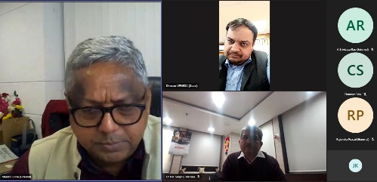

**Snapshot of activities performed-**

## 

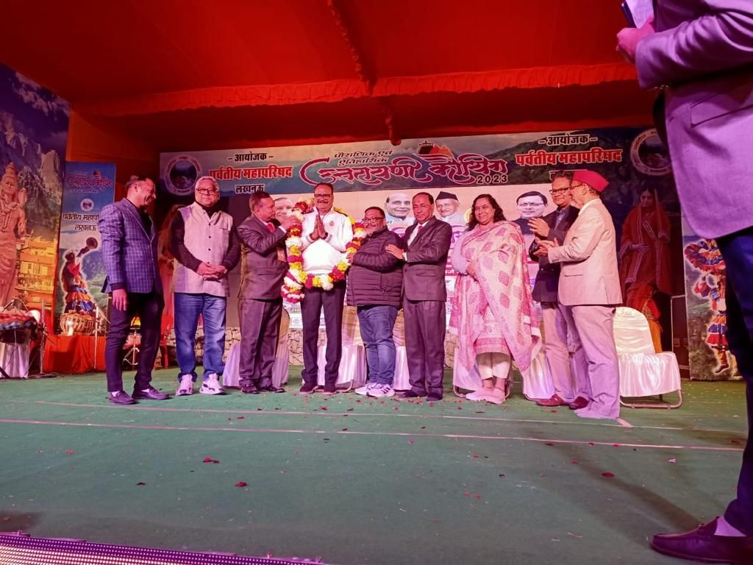

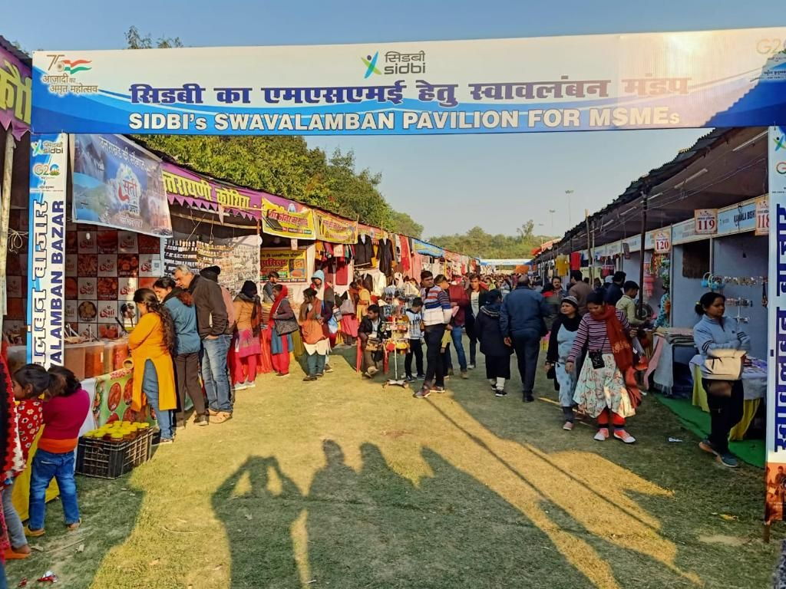 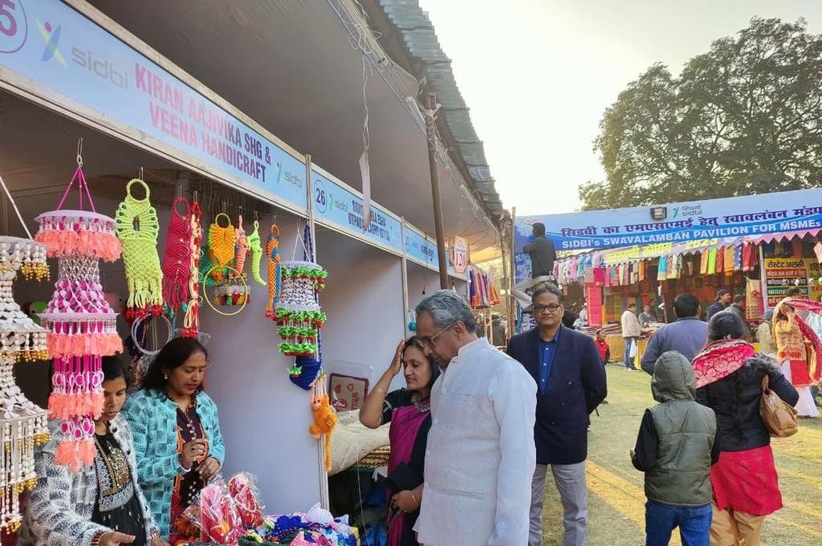

**Contact us**

*****************

To know more, please visit [**www.grantthornton.in**](http://www.grantthornton.in/) or contact any of our offices as mentioned below:

|  |  |  |  |  |
| --- | --- | --- | --- | --- |
| **NEW DELHI**  National Office, Outer Circle, L 41, Connaught Circus, New Delhi - 110001 T +91 11 4278 7070 | **NEW DELHI**  6th Floor, Worldmark 2, Aerocity,  New Delhi - 110037 T +91 11 4952 7400 | **AHMEDABAD**  7th Floor, Heritage Chambers,  Nr Azad Society, Nehru Nagar, Ahmedabad - 380015 | **BENGALURU**  5th Floor, 65/2, Block A, Bagmane Tridib, Bagmane Tech Park, CV Raman Nagar, Bengaluru - 560093  T+91 80 4243 0700 | **CHANDIGARH**  B-406A, 4th Floor, L&T Elante Office Building, Industrial Area Phase I, Chandigarh - 160002  T +91 172 4338 000 |
| **CHENNAI**  7th Floor, Prestige Polygon,  471, Anna Salai, Teynampet, Chennai - 600018  T +91 44 4294 0000 | **DEHRADUN**  Suite No 2211, 2nd Floor, Building 2000, Michigan Avenue, Doon Express Business Park,  Subhash Nagar, Dehradun - 248002  T +91 135 2646 500 | **GURGAON**  21st Floor, DLF Square, Jacaranda Marg, DLF Phase II,  Gurgaon - 122002  T +91 124 462 8000 | **HYDERABAD**  7th Floor, Block III, White House,  Kundan Bagh, Begumpet, Hyderabad - 500016  T +91 40 6630 8200 | **KOCH**I  6th Floor, Modayil Centre Point, Warriam Road Junction, MG Road Kochi - 682016  T +91 484 406 4541 |
| **KOLKATA**  10C Hungerford Street, 5th Floor,  Kolkata - 700017  T +91 33 4050 8000 | **MUMBAI**  11th Floor, Tower II,  One International Center, SB Marg Prabhadevi (W), Mumbai - 400013  T +91 22 6626 2600 | **MUMBAI**  Kaledonia, 1st Floor, C Wing, (Opposite J&J Office),  Sahar Road, Andheri East,  Mumbai - 400 069 | **NOIDA**  Plot No 19A, 2nd Floor, Sector - 16A,  Noida - 201301  T +91 120 485 5900 | **PUNE**  3rd Floor, Unit No 309- 312, West Wing, Nyati Unitree, Nagar Road, Yerwada  Pune - 411006  T +91 20 6744 8800 |

For more information or for any queries, write to us at [**contact@in.gt.com**](mailto:contact@in.gt.com)

|  |  |
| --- | --- |
| Twitter-outline | **Follow us @GrantThorntonIN** |

**Small Industries Development Bank of India (SIDBI),** established under an Act of Parliament in 1990, acts as the Principal Financial Institution for Promotion, Financing and Development of the Micro, Small and Medium Enterprise (MSME) sector as well as for co-ordination of functions of institutions engaged in similar activities. In the context of the changing MSME lending landscape, the role of SIDBI has been realigned through adoption of SIDBI Vision 2.0 which envisages an integrated credit and development support role of the Bank by being a thought leader, adopting a credit-plus approach, creating a multiplier effect and serving as an aggregator in MSME space.





***Disclaime****r: This document is prepared under SIDBI intervention in which Grant Thornton Bharat LLP is the implementing agency. The document users/third parties shall verify the facts and figures at their end and shall be solely liable for any action taken by it based on this document. SIDBI, its directors, employees or any office shall not be liable for loss of whatsoever nature arising by using the content of this document.*